Systems Analysis and Design
Phase 1 Activity Diagram
A00051090
Mattia Contestabile

The activity diagram is divided into four swimlanes representing the different activities employed by the different actors and the App. The actors are: Customer, Restaurant Manager/Partner/ Delivery Driver, and the App: System.

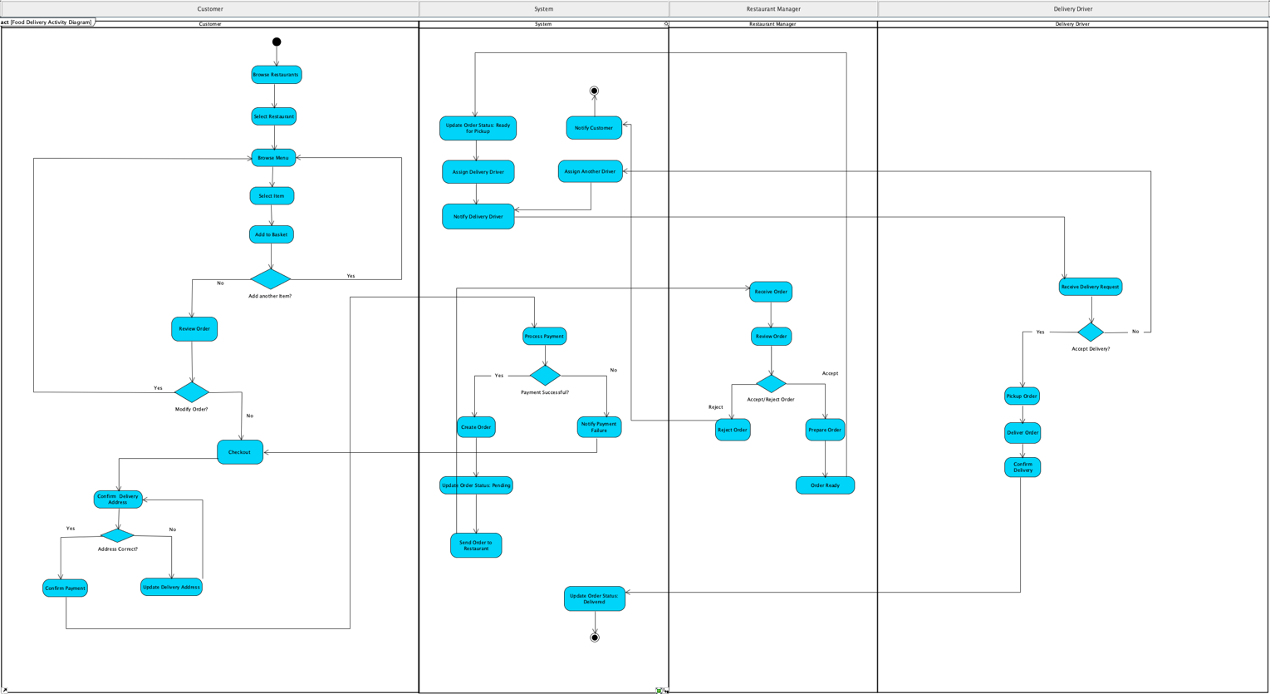

The customer starts the process by interacting with the app system, by first browsing restaurants and selecting a restaurant, then the customer can browse the menu and select an item to add to the basket. The customer can also choose to include more items, and once done, can review the order and decide if something is missing to modify the order by going back to browsing the menu, or, in case she/he is done, proceed with checkout. Once at checkout, the customer is prompted by the system to confirm the delivery address. If the address shown by the system is not correct, then the customer will be prompted by the system to update the delivery address. Once the correct delivery address has been inserted, the customer will proceed with confirming the payment of choice.

System: The system will receive the customer-selected payment instructions and process the payment via the payment gateway (an external entity). The payment can be either successful or not. In case of payment failure, the system will notify the customer and bring the customer back to the checkout step. In case of payment success, the system will create the order accordingly and proceed with updating the order status to pending and then sending the order to the restaurant. The system will also update the order status to ready for pickup once the restaurant manager/partner is done preparing the order. Following updating the system to be ready for pickup, the system will assign a delivery driver and send a notification to the delivery driver, prompting them to either accept or decline the order. In case of success, the delivery driver will continue the process. In case the delivery driver refuses to take the order, the system will attempt to assign another delivery driver until someone accepts to fulfil the order. The system will also update to the final order status delivered once the delivery driver successfully delivers the order to the customer by completing the process. An alternative flow to consider is in case the restaurant partner/manager declines to take the order. In that case, the customer is notified by the system by closing the order and terminating the process.

The Restaurant Manager/Partner will receive a notification by the system and can review the order by either accepting or rejecting it. If rejected, the customer will be notified by the system as aforementioned. If the order gets approved, the restaurant manager will proceed with preparing the order, and once the order is ready, the system will notify the restaurant manager, who will update the order status to “Order Ready for Pickup”.

Delivery Driver, at this stage, the system will, upon changing the order status to ready to pickup, assign a delivery driver that will be selected by the app by metrics such as “proximity, distance from the restaurant and customer location”. Once one delivery driver has been selected, the delivery driver will be notified by the system, and the delivery driver can either accept or refuse the delivery order. In case of refusal to complete the order, the system will be notified, and another delivery driver will be assigned until a delivery driver accepts the order. In case of approval of the order, the delivery driver will pick up the order, deliver the order to the customer, and finally confirm the delivery with the system, which will complete the last update, which is Update Status Delivered.

